**Program - 1**

**PARAMBARIYA UNAVU THIRUVIZHA-(The Authentic Taste)**

**Venue: Nagarathinam Angalammal Arts and Science College**

**Date: 30.09.2021 Time: 10.00 a.m**

**No. of. Beneficiaries:95**

The Women’s Studies Centre of Madurai Kamaraj University, Madurai and Department of Hotel Management and Catering Science (“The Nalas Squad”) of Nagarathinam Angalammal Arts and Science College(NAAS), Madurai, jointly organized a program on **“Parambariya Unavu Thiruvizha”(**The Authentic Taste) with Integrated Child Development Services Scheme, Tamil Nadu. The program began with the Tamilthai vazthu.

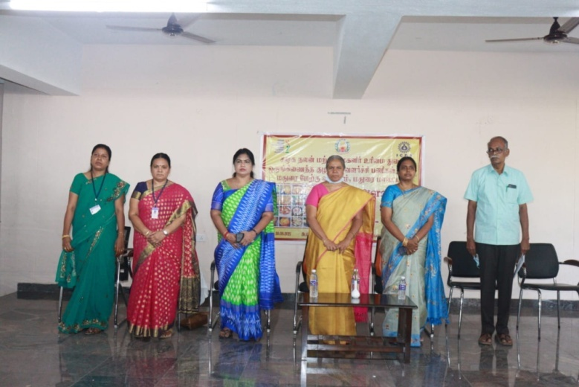

After the Tamilthai Vazthu welcome address was delivered by Dr.R.Sevvel, principal, NAAS. In his welcome address he welcomed Dr.N.Jegatheesan, Secretary, NAAS College. Dr.R.Radhika Devi, Director i/c, Women’s Studies Centre, Madurai Kamaraj University, Madurai, Mrs.F.Helen Rose M.A.,BL., District Program Officer, Madurai, Dr.K.Valanthina Kuraizi, Child Development Project Officer, Madurai West and the participants for the program. He concluded by saying that programs like this are important to make us to realize the importance of our tradition which we forget today.

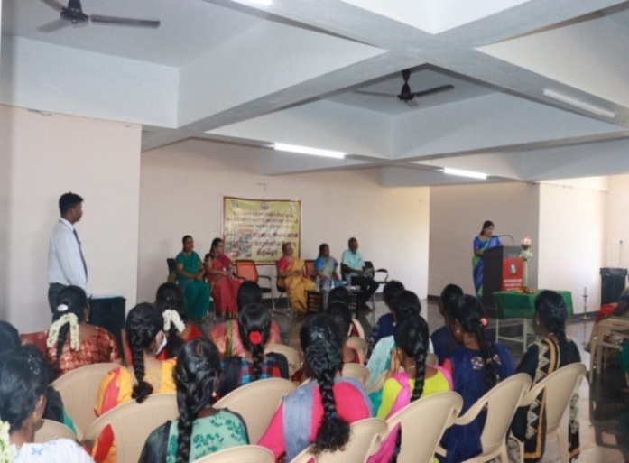After the welcome address the presidential address was given by Dr.N.Jegatheesan, Secretary NAAS College. In his presidential address the secretary pointed that the Madurai Kamaraj University and Nagarathinam Angalammal Arts and Science College are working for the upliftment of people in the surrounding areas by concentrating on important issues that the society is lagging behind. This program on “Parambariya Unavu Thiruvizha” was organized with the aim of introducing traditional foods to the people of Madurai District. The program like this gives awareness to the people about the importance of traditional foods .It also insists people to regularly intake the traditional food items. Though the fast foods are tastier and easier to prepare it creates bad health effects to the body. Today we can see people at young age having many health ailments and going to the hospital becomes a part and parcel of life. The reason is increase in intake of fast foods which is easily available anywhere. The type of food we intake in the young age decides our health status above the age of fifty. Each traditional item is rich in nutrition. We must show interest in identifying the different types of traditional foods and how it is prepared especially the ingredients and methods used during the preparation. Traditional food items have the capacity to cure many health problems. He concluded by requesting everyone to include traditional food items regularly for a healthier life. After the presidential address the Inaugural Address was given by Dr.R.Radhika Devi, Director-in-charge, Women’s Studies Centre, Madurai Kamaraj University. In her Inaugural address she spoke about the need for traditional food items like ragi, millet, kambu, samai etc.

Due to the mechanical life that we are leading we forget what our ancestors followed as dietary habits. For example, they did not include sugar in their diets instead they used jaggery for adding sweet flavor to the food. But today white sugar has become one of the important items to add sweet flavor to the food. If we ask the doctors, they will tell how bad white sugar to our health is. Traditional food brings stamina and increases immunity power to our body. The traditional food items will keep us young and fit. It has no toxins, whereas the food items like pizza, burger and all other fast foods have toxins as they include certain powders to add taste to the food. Today we are exposed to many hybrids food items which create more health problems to our body. Young girls attain puberty at an earlier age and researches say that it is because of eating fast foods and broiler chicken items.

Now we have broiler fishes sold in the market, so every food item instead of being grown in a natural way are grown in an artificial manner either for marketing or for some other reason. We are much exposed to artificial foods and to stop this we have to adapt the food style consisting of traditional foods. She concluded by saying that it is the need of the hour to change our food habits towards traditional foods as health is base for everything in our life. If our health is bad our survival becomes difficult. Many would argue with me that I am doing regular exercises to maintain health. But like regular exercises it is equally important that we must be concerned about what we take as food to our body. After the Inaugural Address, Special address was given by Mrs.F.Helen Rose M.A., B.L., District Program Officer, Madurai. She in her speech appreciated the initiatives taken by the educational institutions to introduce the traditional food items to the people.

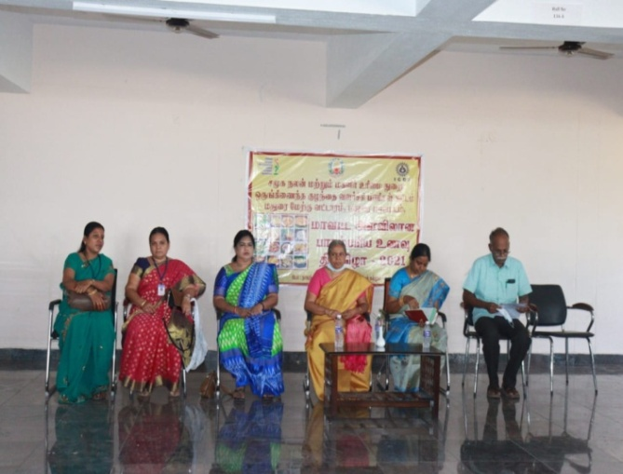

These traditional foods are grown from non-hybrid seeds in a traditional way. Though we have hybrid varieties in traditional food also we are pushed into a situation to eat our traditional foods as the modern food style which we follow creates lot of health issues to our body. Our present food style could be said as a mixture of our traditional and modern food items. Slowly the modern food items like noodles, pasta, shawarma etc., are pushing aside our traditional food items. The younger generation does not know even the names of our traditional food. Many would say the fast foods are tastier but I could assure you that our traditional food items are tastier than fast foods. We can do many varieties of food using our traditional food items. For example, we can prepare variety rice using millets. Each traditional food items has its Traditional food items have the capacity to cure many health problems. He concluded by requesting everyone to include traditional food items regularly for a healthier life. After the presidential address the Inaugural Address was given by Dr.R.Radhika Devi, Director i/c, Women’s Studies Centre, Madurai Kamaraj University. In her Inaugural address she spoke about the need for traditional food items like ragi, millet, kambu, samai etc. Due to the mechanical life that we are leading we forget what our ancestors followed as dietary habits. For example, they did not include sugar in their diets instead they used jaggery for adding sweet flavor to the food. But today white sugar has become one of the important items to add sweet flavor to the food. If we ask the doctors, they will tell how bad white sugar to our health is. Traditional food brings stamina and increases immunity power to our body. The traditional food items will keep us young and fit. It has no toxins, whereas the food items like pizza, burger and all other fast foods have toxins as they include certain powders to add taste to the food. Today we are exposed to many hybrids food items which create more health problems to our body. Young girls attain puberty at an earlier age and researches say that it is because of eating fast foods and broiler chicken items.

Now we have broiler fishes sold in the market, so every food item instead of being grown in a natural way are grown in an artificial manner either for marketing or for some other reason. We are much exposed to artificial foods and to stop this we have to adapt the food style consisting of traditional foods. She concluded by saying that it is the need of the hour to change our food habits towards traditional foods as health is base for everything in our life. If our health is bad our survival becomes difficult. Many would argue with me that I am doing regular exercises to maintain health. But like regular exercises it is equally important that we must be concerned about what we take as food to our body. After the Inaugural Address, Special address was given by Mrs.F.Helen Rose M.A., B.L., District Program Officer, Madurai. She in her speech appreciated the initiative taken by the educational institutions to introduce the traditional food items to the people.

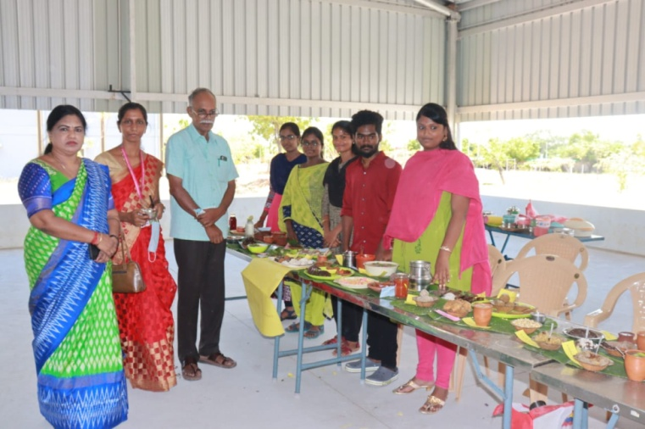

These traditional foods are grown from non-hybrid seeds in a traditional way. Though we have hybrid varieties in traditional food also we are pushed into a situation to eat our traditional foods as the modern food style which we follow creates lot of health issues to our body. Our present food style could be said as a mixture of our traditional and modern food items. Slowly the modern food items like noodles, pasta, shawarma etc., are pushing aside our traditional food items. The younger generation does not know even the names of our traditional food. Many would say the fast foods are tastier but I could assure you that our traditional food items are tastier than fast foods. We can do many varieties of food using our traditional food items. For example, we can prepare variety rice using millets. Each traditional food items has its own specialty. Foxtail Millet increases lactation for mothers. Beta-carotene is high in Foxtail millet .It converts into vitamin A (retinol) in our body. We need vitamin A for good vision and eye health, for a strong immune system, and for healthy skin and mucous membranes. Similarly little millet is one of the important traditional food and is rich in iron. It is more fibrous than the normal white rice. It is a best medicine for diabetes. It increases the Red Blood Corpuscles (RBC) in our body. The District Program Officer concluded by saying that there is no other food that replaces our traditional food items.

The program came to an end with the vote of thanks by Dr.K.Valanthina Kuraizi, Child Development Project Officer, and Madurai West. She in her speech thanked the Madurai Kamaraj University, Nagarathinam Angalammal Arts and Science College and the Integrated Child Development Services Scheme for organizing the program.

**Program - 2**

**WORKSHOP**

**ON**

**DATA ANALYSIS TECHNIQUES FOR RESEARCH**

**DATE: 28.01.2022-29.01.2022 TIME: 10.00 A.M-5.00 P.M**

**VENUE: Nagarathinam Angalammal Arts and Science College, Madurai**

**No. of .Beneficiaries: 26**

The Women’s Studies Centre of Madurai Kamaraj University in collaboration with Internal Quality Assurance Cell (IQAC) of Nagarathinam Angalammal Arts and Science College, Madurai conducted two days workshop on “Data Analysis Techniques for Research”. The Workshop began with the Inaugural session .Dr.N.Jegatheesan, Secretary, Nagarathinam Angalammal Arts and Science College presided over the Inaugural Session. Dr.R.Radhikadevi Director i/c, Women’s Studies Centre, Madurai Kamaraj University and Dr. R. Sevvel Principal, Nagarathinam Angalammal Arts and Science College, Madurai felicitated the function. In the Inaugural session welcome address was given by Dr.P.Karthiga, Assistant professor, Department of Tamil, Nagarathinam Angalammal Arts and Science College, Madurai. In her welcome address she welcomed the Resource Person Dr.P.Muthupandian, Assistant Professor, Sikkim Central University, Sikkim and the participants for the workshop. The Inaugural session came to end with a brief introduction of the Resource Person by Dr.P.S.Senthilkumar IQAC Coordinator, Nagarathinam Angalammal Arts and Science College, Madurai.

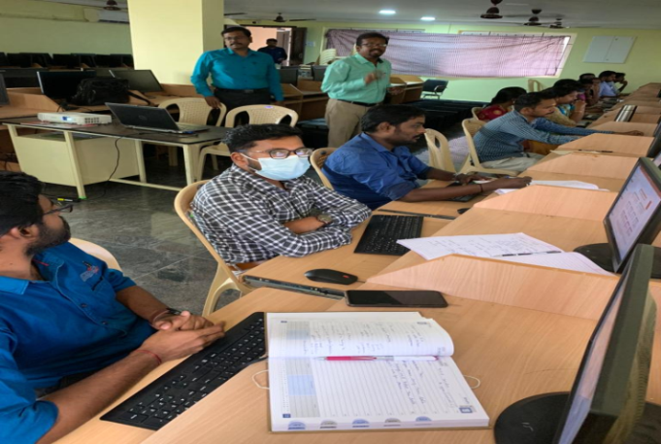

After the inaugural address Dr.P.Muthupandian began his speech by saying about data in Research Methodology as follows. Data is any kind of information that we collect and observe from people for accurate research findings. Population denotes more individuals from which we select sample for the Research Study. The Sample is the representative element of population.

The Resource Person mentioned about the types of statistics as follows. The types of statistics are Mean(it is the aggregate or total of all the scores),Standard Deviation(A number used to describe how measurements for a group are spread out from the average, Kurtosis(it is a statistical measure that defines how heavily the tails of distribution differ from the normal distribution), Skewness (is a measure of deviation of a random variable given distribution from the normal distribution).These four types of statistics can be said as colour tools to describe the collected data. It is used in Descriptive Statistics.

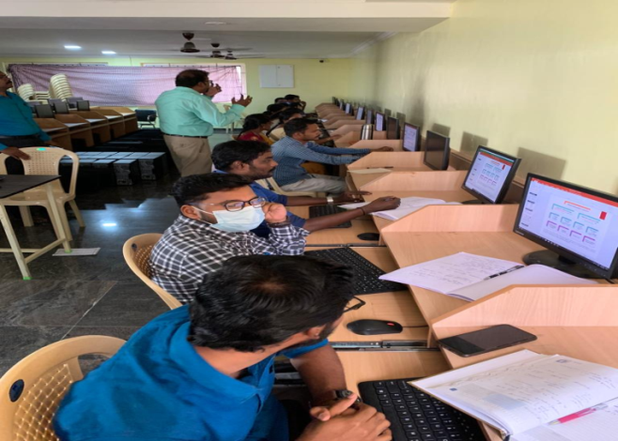

The Resource Person continued his speech by explaining about Descriptive Statistics as follows. The Descriptive statistics describes the data; it summarizes the information from the collected data. The Resource Person while speaking on Inferential Statistics said that it uses measurements from the samples and make generalization from the larger population. Example: We can ask review about a movie from the group of people in the theatre and generalize about the movie. Inferential statistics is divided into two one is Hypothesis Testing and the other is Estimation. Hypothesis is a tentative statement and through hypothesis testing we have to prove whether the statement is true or false. In Hypothesis Testing we have Test of Mean (comparing the mean of a sample to a pre specified values for example a normal weight of the new born baby is 3,410grams having this as a specific value, comparing the birth weight of new born babies.), Test of Relationship or Association (to find a relationship between two variables) and Test of proportion(it will assess whether or not a sample from the population represents the true proportion from the entire population).

He said in his speech that there are two types of hypothesis one is null hypothesis (it tells that there is no statistical relationship between one set of single observed variable or between two sets of observed data)and alternate hypothesis is nothing but alternate to what we assume as an null hypothesis.

The Resource Person continued to explain his speech by saying about two tailed test or Non-Directional Hypothesis as follows. The two tailed test is a test conducted to show that whether the mean of the sample is significantly greater than and significantly less than the mean of the population. The Resource Person while speaking on estimation said that estimation in statistics is nothing but procedures to calculate the value of property of a population from observation of population. A point estimate for example is the number most likely to express the value of the property. The Resource Person elaborated on Doughnut Chart as follows. Doughnut chart is an in- built chart type in excel and it is used to express the “part to whole relationship” for example the departments available in an educational institution. The Resource Person continued to explain about the pie chart and how to use the Pie Chart in Microsoft Excel as follows (click insert, select the option insert pie and then click pie chart. The Resource Person while explaining about the Categorical Variable said that it represents the type of data that may be divided into groups. There are three types of Categorical Value they are Binary Value (which can take two variables like true or false), Nominal value (it can be classified without an order or rank) Ordinal Value (it has a predetermined or natural order).The Resource Person also spoke about Correlation by saying the meaning of correlation as follows. Correlation is a statistical term describing the degree to which two variables move in coordination with one another. It is used to describe the linear relationship between two continuous variables. Example: height and weight. There are two types of correlation one is positive correlation. It is a relationship between two variables that tend to move in the same direction. Example: People who are taller tend to be heavier. The other is negative correlation in which an increase in one variable is associated with the decrease in the other variable. Example: Height above sea level. The Resource Person elaborated on Parametric Tests as follows. The Parametric Tests are those that make assumptions about the parameters of the population distribution from which the sample is drawn. For Parametric Test the Data should be normally distributed. The Data should be homogenous or less heterogeneous. An example of Parametric Test is “Z Test”. Z Test is a parametrical test to determine whether the Mean of two populations are different when the variances are known and the sample size is large. The Resource person explained the meaning of variances as follows. Variances is a measure of variability calculated by taking the average of squared deviations from the Mean.

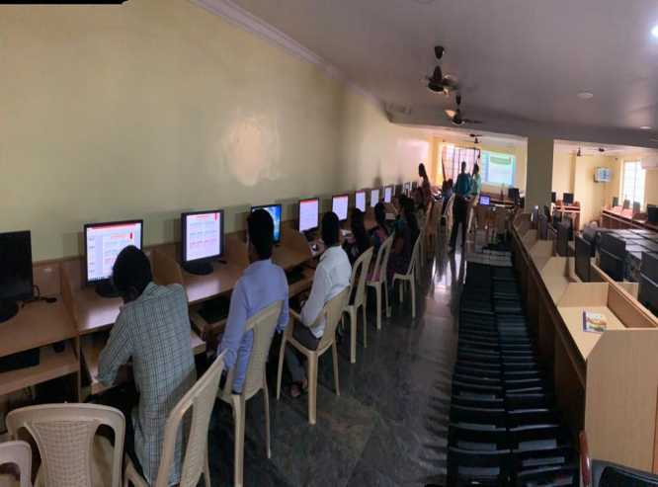

The Resource Person continued his speech by saying that Non-Parametric Tests are experiments that do not require the underlying population for assumptions. It does not rely on any data referring to any particular group of probability distributions. An example of Non-Parametric Test is Chi Square Test. Chi Square Test is designed to test for a statistically significant relationship between nominal and ordinal variables in simple terms it tells us whether two variables are independent of one another. The Resource Person while speaking about One Sample t Test said that it is a statistical hypothesis test used to determine whether an unknown population mean is different from a specific value. The Resource Person concluded by saying that the statistical knowledge provides a mechanism to give accurate evidence of a particular study. Many consider that using statistics is risk and have a reluctant attitude towards it. But actually, it is very easier to understand. We should begin to apply statistics even for smaller researches at the Under Graduate Level and move on to higher level statistical tests. The Workshop came to an end with the vote of thanks by Mr.S.T.Siddarthan, Assistant Professor, Department of Commerce, Nagarathinam Angalammal Arts and Science College, Madurai.